**Product & Sales Analysis**

1. Which products generate the highest revenue?

(SQL) (Python)

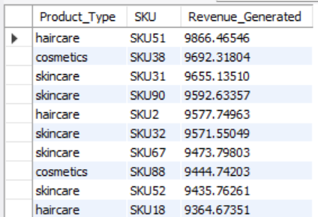 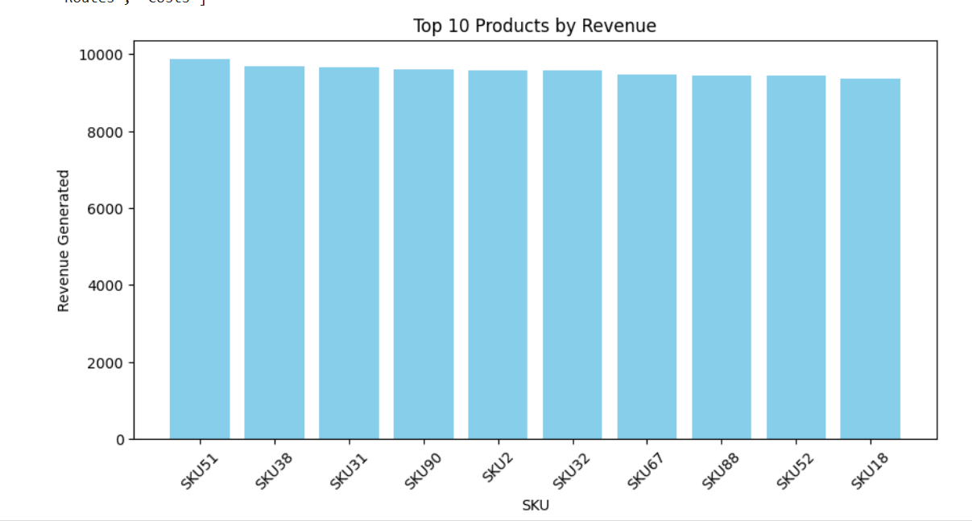

The highest revenue-generating products are **haircare SKU51, cosmetics SKU38, and skincare SKU31**, with revenues exceeding **$9600**. Haircare and skincare dominate the top-selling categories.

1. What is the correlation between price and the number of products sold?

(SQL) (Python)

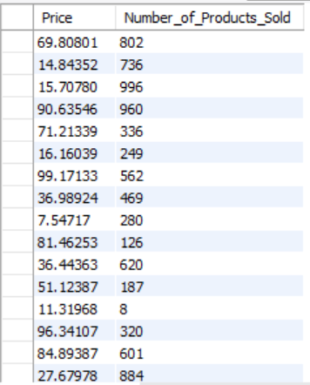 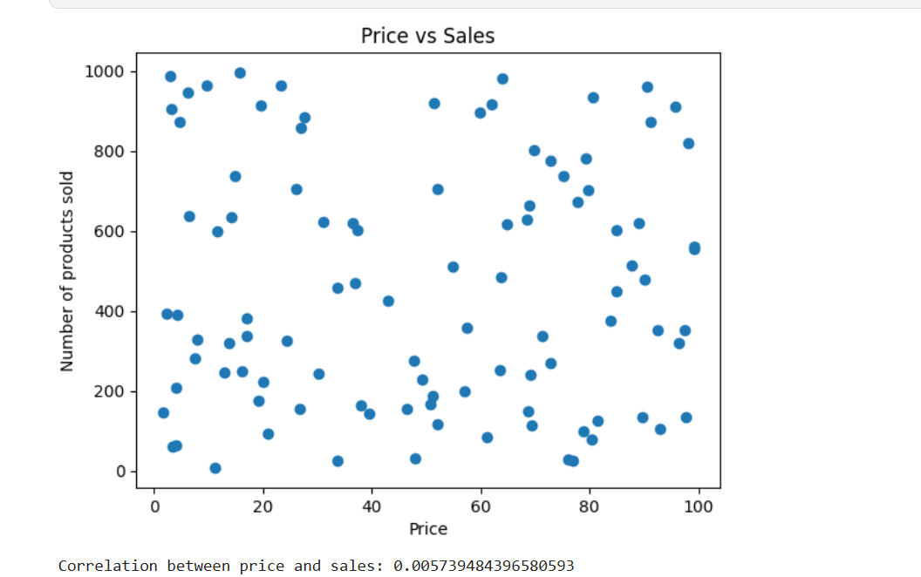

The correlation between **price and the number of products sold** is **0.0057**, indicating **almost no relationship** between price and sales volume. Price changes do not significantly impact sales.

1. How does product availability affect sales volume?

(SQL) (Python)

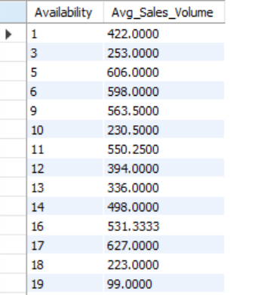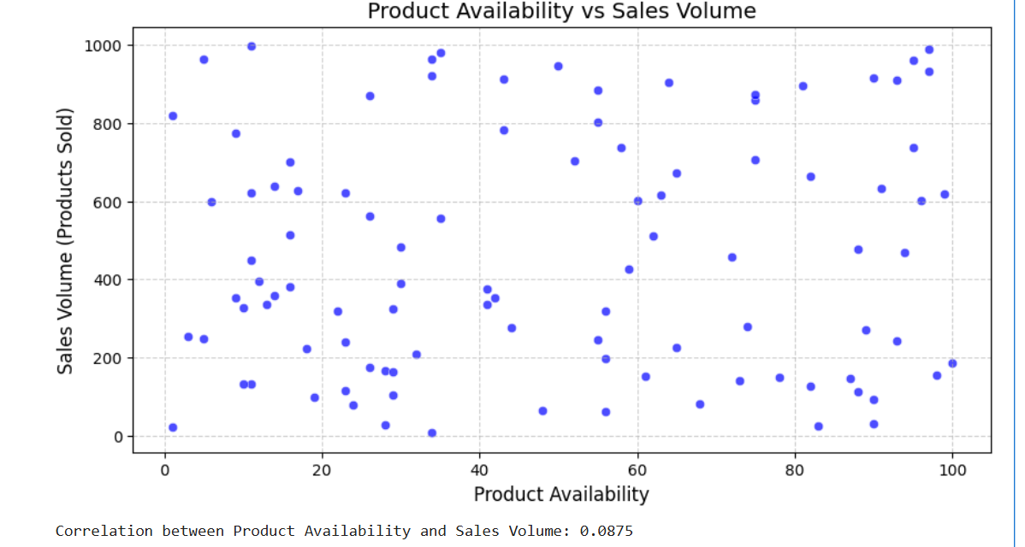

**Product availability has little correlation with sales volume, as shown by the scattered data points.** This suggests that other factors, such as demand or pricing, may have a greater impact on sales.

1. Are there specific SKUs that consistently perform better across different customer demographics?

(SQL) (Python)

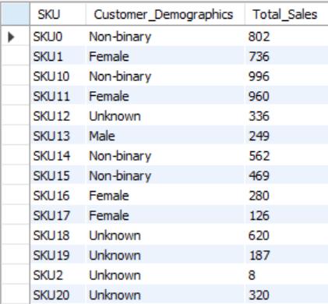 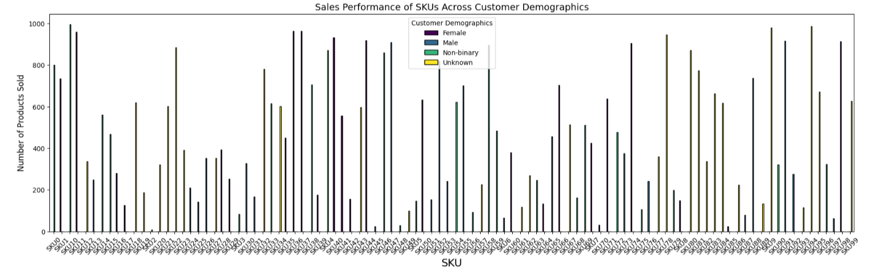

**Some SKUs, like SKU10 and SKU11, consistently perform well across multiple customer demographics.** The bar chart confirms that specific products appeal to diverse groups.

1. What are the best-selling products in each customer demographic?

(SQL)

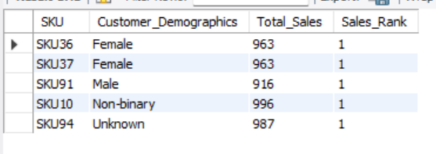 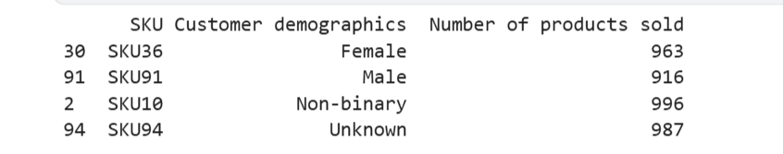

**Each customer demographic has a distinct best-selling product, with SKU10 leading among non-binary customers and SKU36 among females.** The table confirms sales rankings for each group.

1. How do product categories impact revenue?  
     
   (Python)  
   A graph of a bar chart

   AI-generated content may be incorrect.  
   The bar chart shows that skincare generates the highest revenue at around 250,000, followed by haircare at 175,000, while cosmetics contributes the least at 150,000, suggesting that skincare is the most profitable category and may benefit from further investment, while cosmetics might need marketing efforts to boost sales.
2. What is the relationship between product categories and defect rates?  
     
   (Python)  
   A graph of blue bars

   AI-generated content may be incorrect.The bar chart shows that haircare has the highest average defect rate at around 2.5%, followed by skincare at 2.3%, while cosmetics has the lowest at 2.0%, indicating that haircare products may require more rigorous quality control to reduce defects, while cosmetics maintain relatively better quality.

**Inventory & Stock Management**

1. What are the stock levels for different SKUs, and how do they compare to sales trends?

(SQL) (Python)

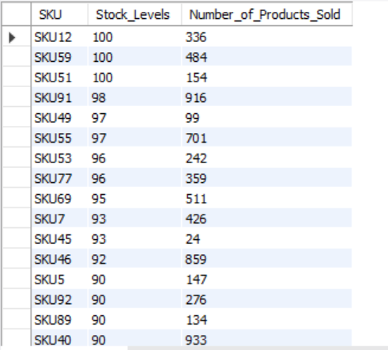 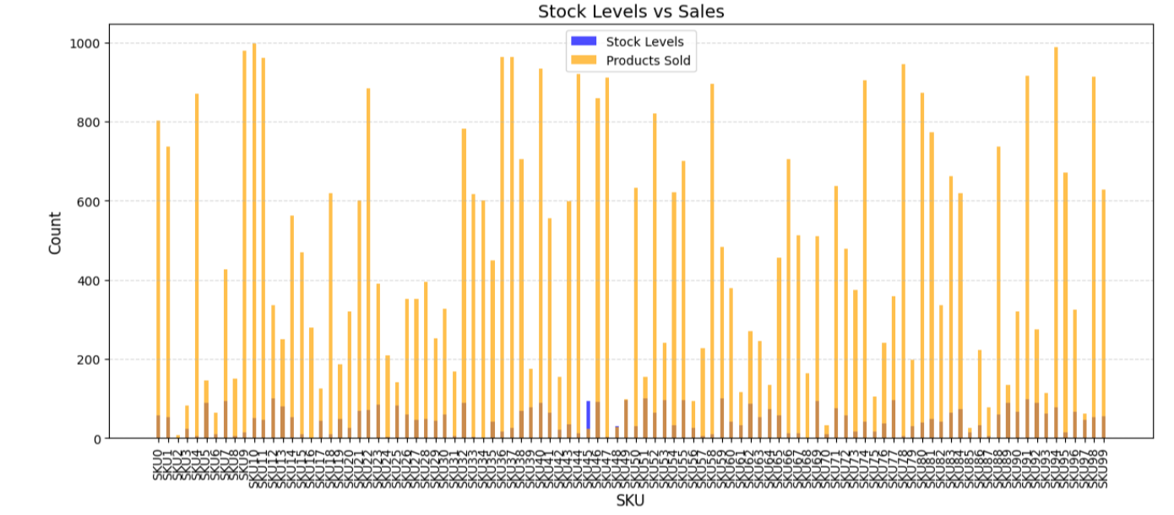

Stock levels vary across SKUs, with some high-selling products having **low stock**, indicating a need for restocking. **Sales trends are inconsistent with stock levels**, suggesting potential supply chain inefficiencies.

1. How often do stockouts occur, and which products are most affected?

(SQL) (Python)

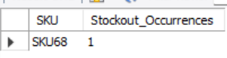 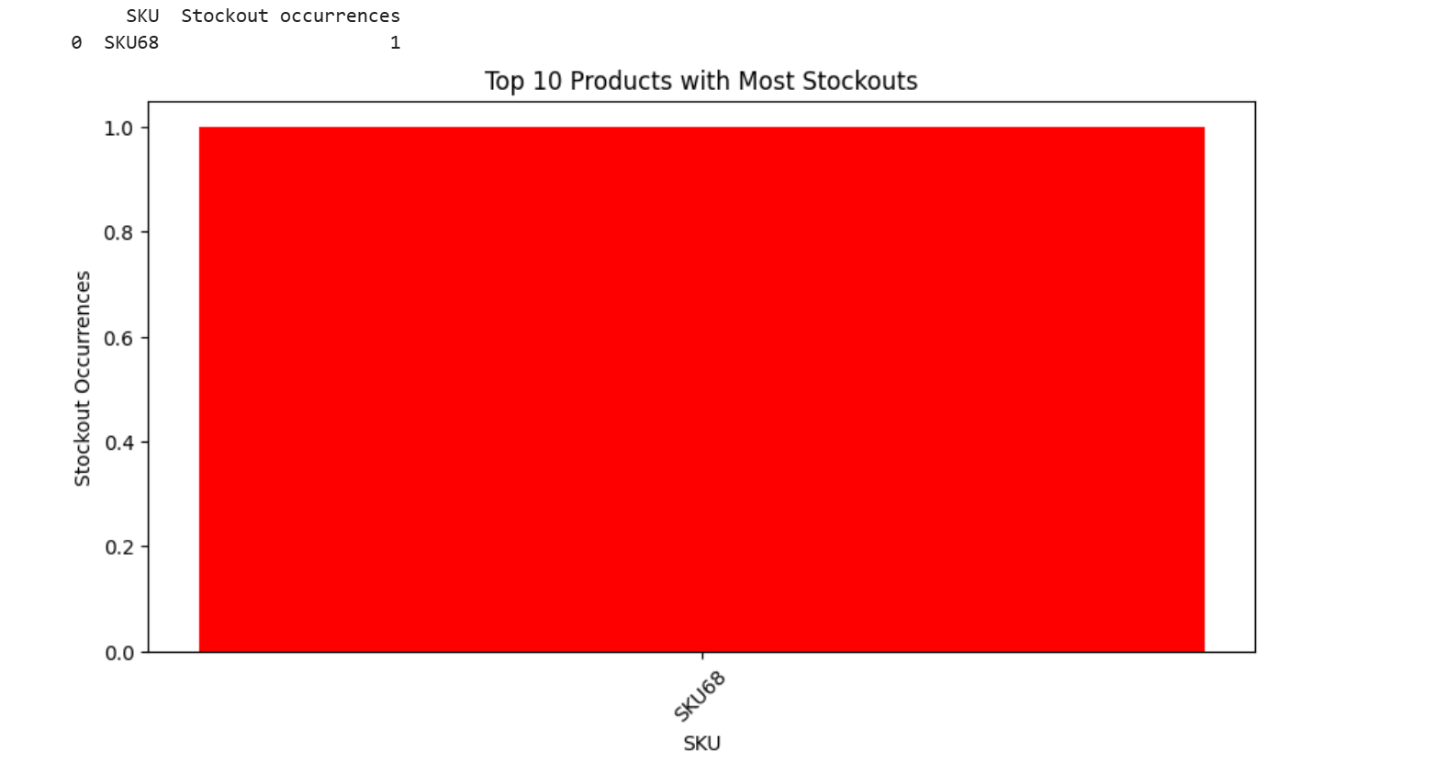

**Stockouts are rare, with SKU68 being the only product affected.** The bar chart highlights its occurrence, indicating potential supply chain inefficiencies.

1. Are there seasonal trends in stock depletion?

(SQL) (Python)

 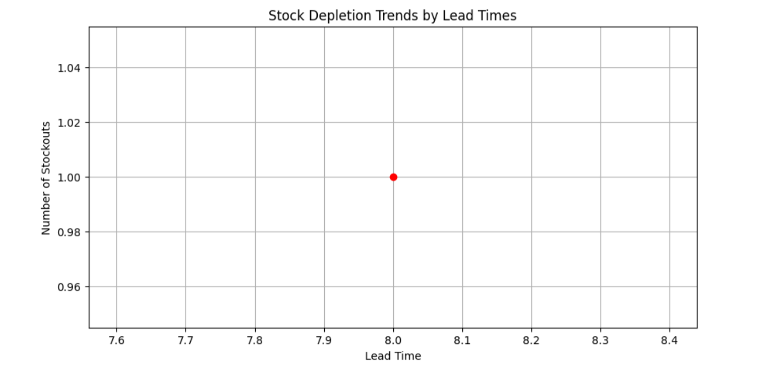

**No strong seasonal trends in stock depletion are observed, with stockouts occurring sporadically.** The data suggests that stock depletion may be influenced by factors other than lead times.

1. How do lead times impact stock levels?

(SQL) (Python)

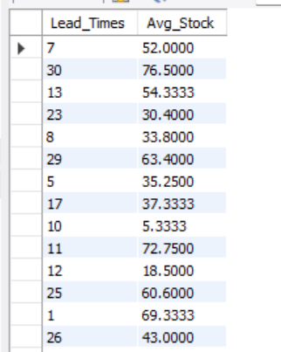 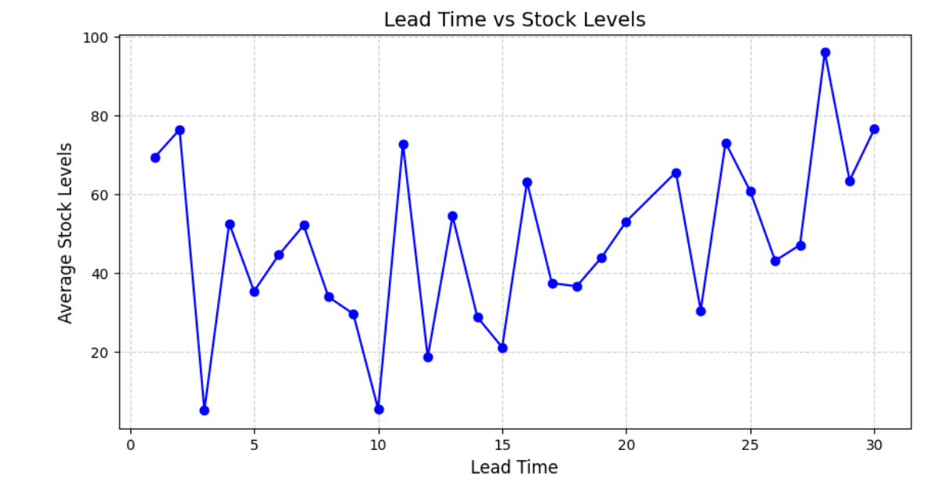

Lead times show a **fluctuating impact on stock levels**, with longer lead times generally associated with **higher average stock** levels. This suggests that businesses may **overstock to compensate for delays** in supply.

1. What reorder quantities optimize inventory costs while preventing stockouts?

(SQL) (Python)

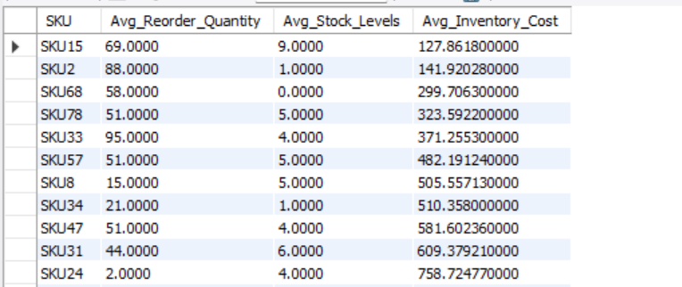 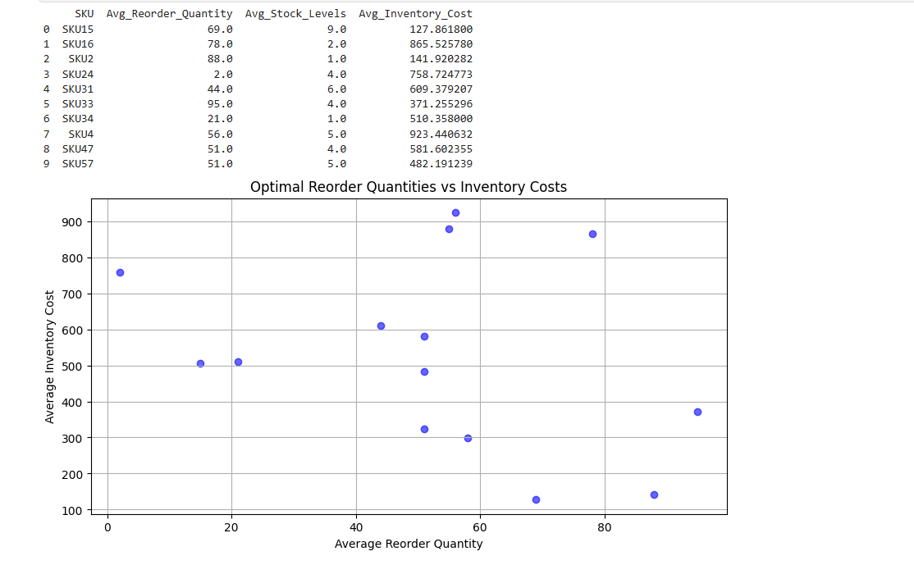

**Optimal reorder quantities balance inventory costs while preventing stockouts.** The scatter plot shows varying reorder levels, indicating that larger reorder quantities generally lead to higher inventory costs.

1. How do product categories affect stock levels?  
     
   (Python)  
     
   A graph of a bar chart

   AI-generated content may be incorrect.  
     
   The bar chart shows that cosmetics maintain the highest average stock levels at around 55 units, followed by haircare at 45 units, while skincare has the lowest at 40 units, suggesting that cosmetics may be overstocked compared to demand, while skincare stock levels might need adjustment to avoid potential shortages.

**Supplier & Manufacturing Analysis**

1. Which suppliers provide the fastest lead times?

(SQL) (Python)

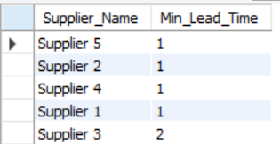 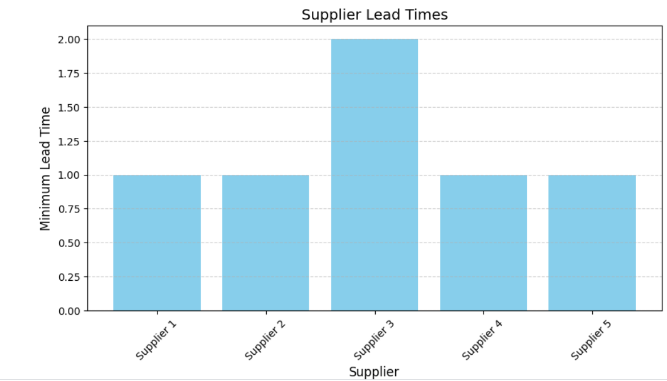

**Suppliers 1, 2, 4, and 5** provide the **fastest lead times** with a minimum lead time of **1 day**, while **Supplier 3** has a slightly longer lead time of **2 days**.

1. Is there a relationship between supplier location and lead time?

(SQL) (Python)

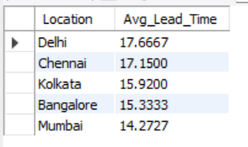 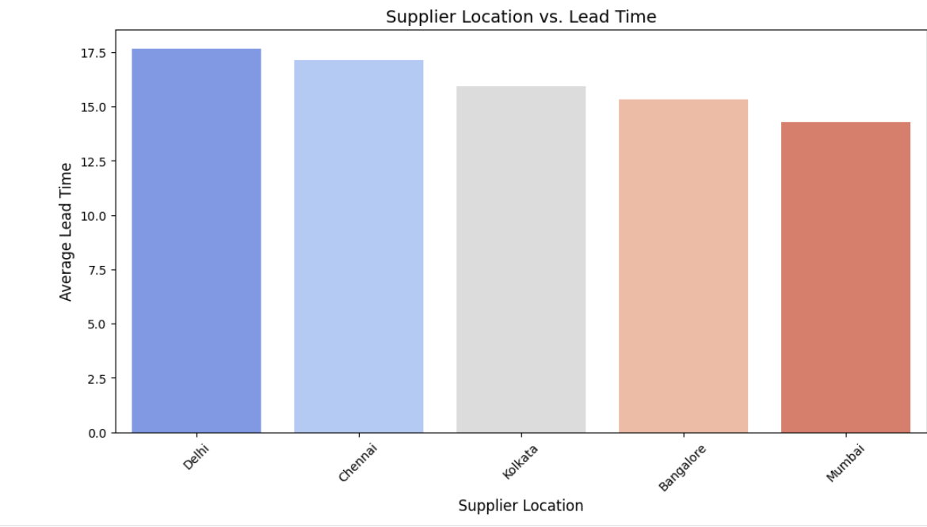

**Suppliers in Delhi and Chennai have the longest lead times, while Mumbai has the shortest.** The bar chart confirms regional differences in supplier efficiency.

1. How do manufacturing lead times compare across different products?

(SQL) (Python)

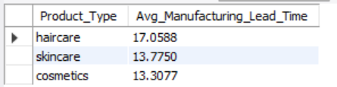 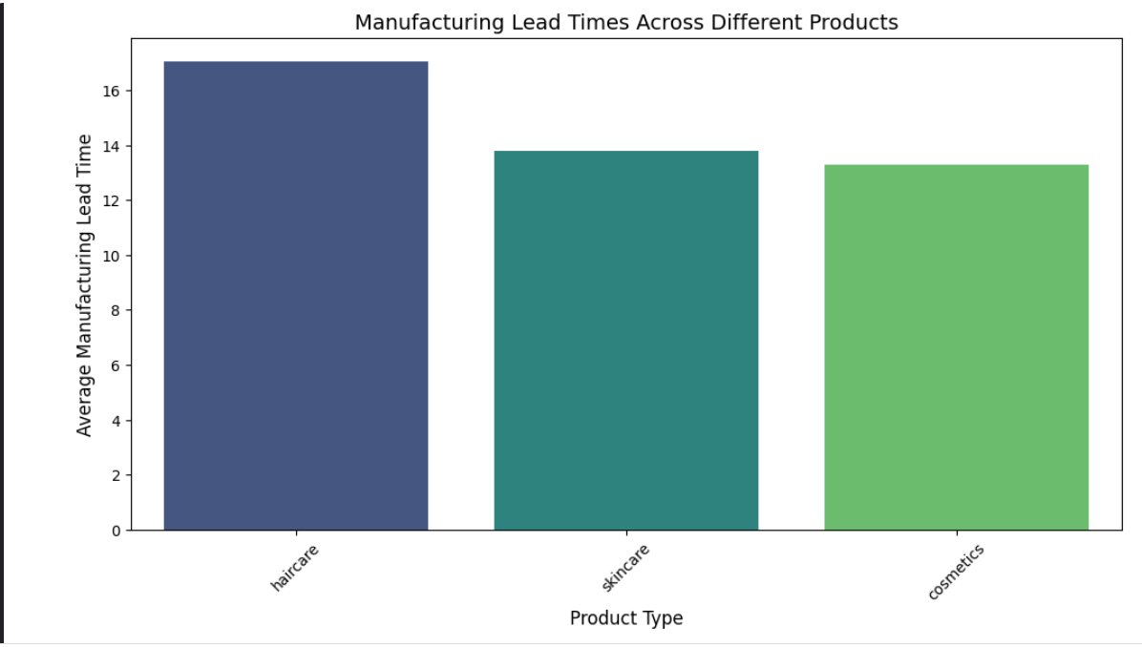

**Haircare products have the longest manufacturing lead times, while skincare and cosmetics take less time.** The bar chart visually confirms these differences in production efficiency.

1. Which suppliers have the lowest defect rates?

(SQL)

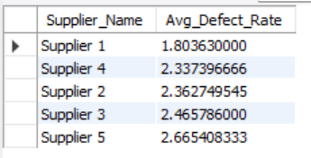 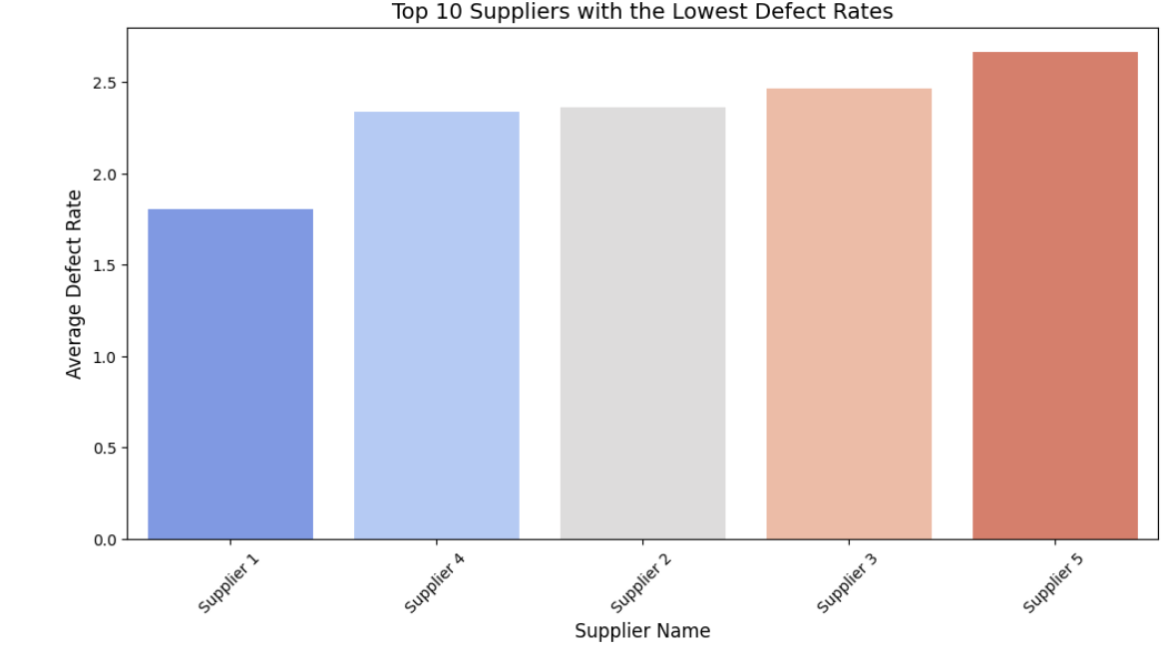

**Supplier 1 has the lowest defect rate, making it the most reliable option.** The bar chart confirms variations among suppliers, helping in quality-driven supplier selection.

1. How do manufacturing costs vary by product type and supplier?

(SQL) (Python)

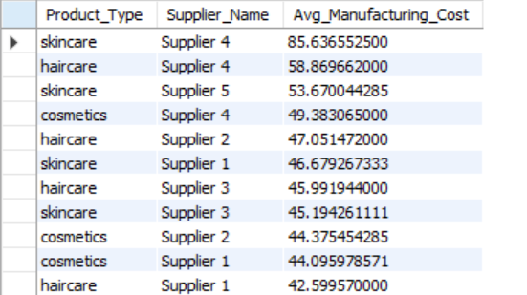 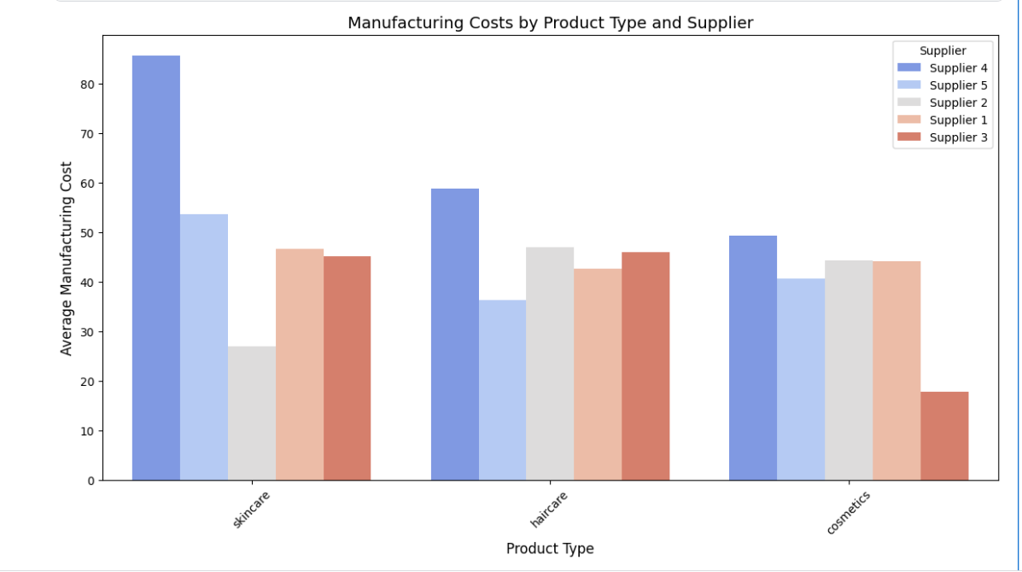

**Manufacturing costs vary significantly by supplier and product type, with Supplier 4 having the highest costs for skincare.** The bar chart highlights cost differences, helping identify the most cost-efficient suppliers.

1. What is the impact of production volumes on defect rates?

(SQL) (Python)

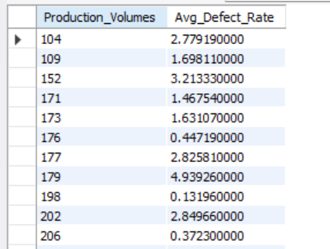 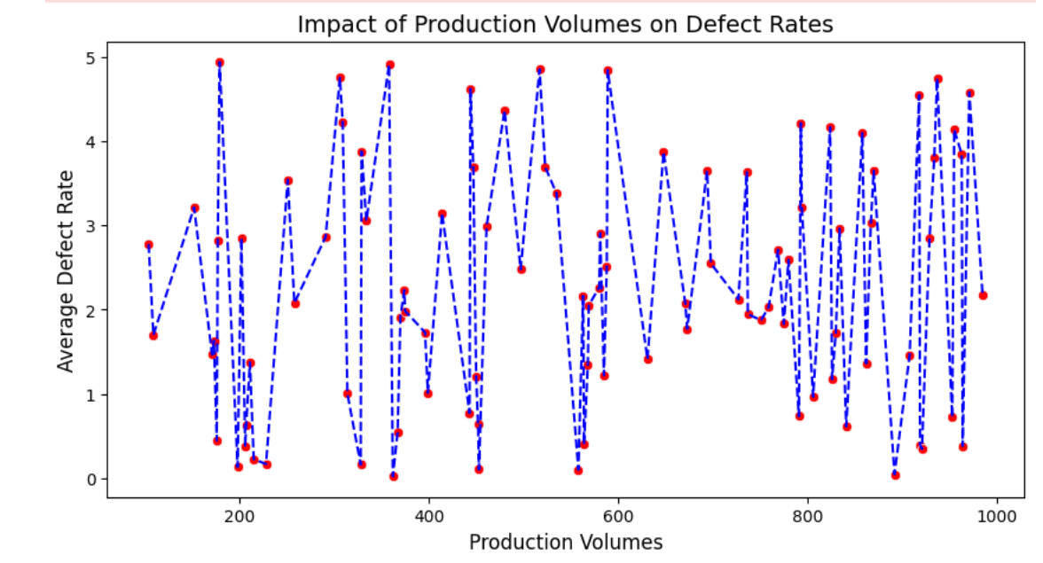

**Defect rates fluctuate with production volumes, showing no clear linear relationship.** Higher production volumes do not consistently lead to higher or lower defect rates, indicating other influencing factors.

1. How do suppliers impact lead times?  
     
   (Python)  
     
   A graph of blue bars with white text

   AI-generated content may be incorrect.  
     
   The bar chart shows that Supplier 3 has the longest average lead time at around 20 days, while Suppliers 1 and 4 have the shortest at around 15 days, indicating that choosing Suppliers 1 or 4 could help reduce production delays for products like cosmetics and skincare, whereas Supplier 3 may cause bottlenecks.
2. What is the relationship between suppliers, product quality, and manufacturing costs?  
     
   (Python)  
     
   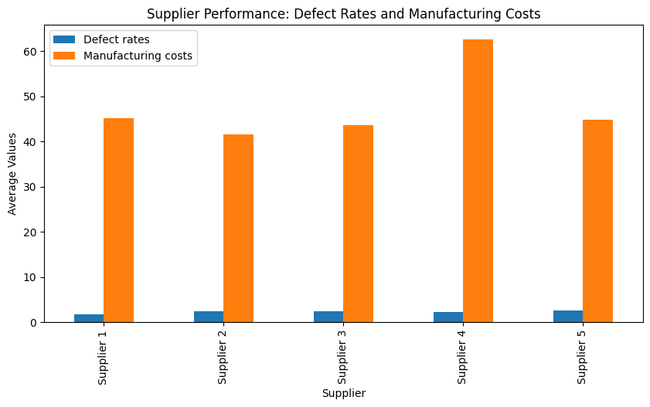  
     
   The bar chart shows that Supplier 4 has the highest manufacturing costs at around 60 and the highest defect rate at 5%, while Supplier 1 has lower costs at 45 with a defect rate of 2%. This suggests a potential trade-off: higher manufacturing costs don’t necessarily guarantee better quality, as Supplier 4 performs poorly in both metrics, whereas Supplier 1 offers a better balance of cost and quality for products like cosmetics and skincare.
3. How does supplier quality impact defect rates?  
     
   (Python)  
     
     
     
     
     
     
     
     
   A graph of blue rectangular bars with white text

   AI-generated content may be incorrect.  
     
   The bar chart shows that Supplier 5 has the highest average defect rate at around 2.5%, while Supplier 1 has the lowest at 1.8%, indicating that supplier quality significantly impacts defect rates, with Supplier 1 offering the best quality for products like cosmetics and skincare, whereas Supplier 5 may require quality improvements to reduce defects.

**Shipping & Logistics**

1. Which shipping carriers provide the fastest delivery times?

(SQL) (Python)

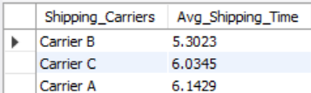 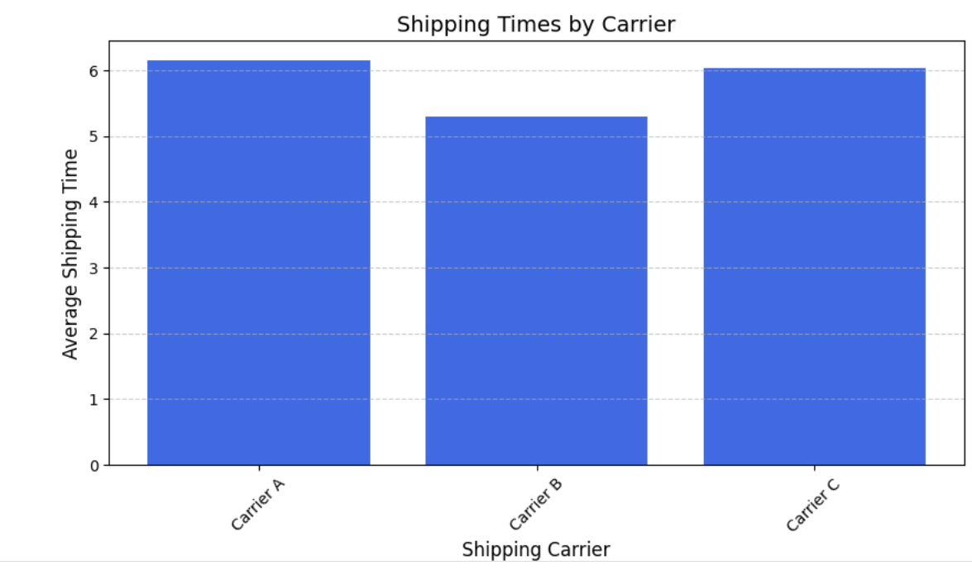

**Carrier B** provides the **fastest delivery time** with an average of **5.30 days**, while **Carrier A and Carrier C** have longer delivery times of **6+ days**.

1. What is the average shipping time per product type or SKU?

(SQL) (Python)

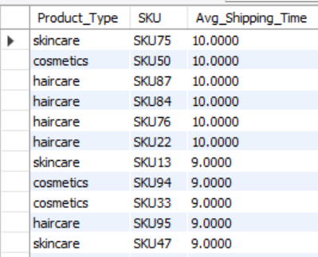 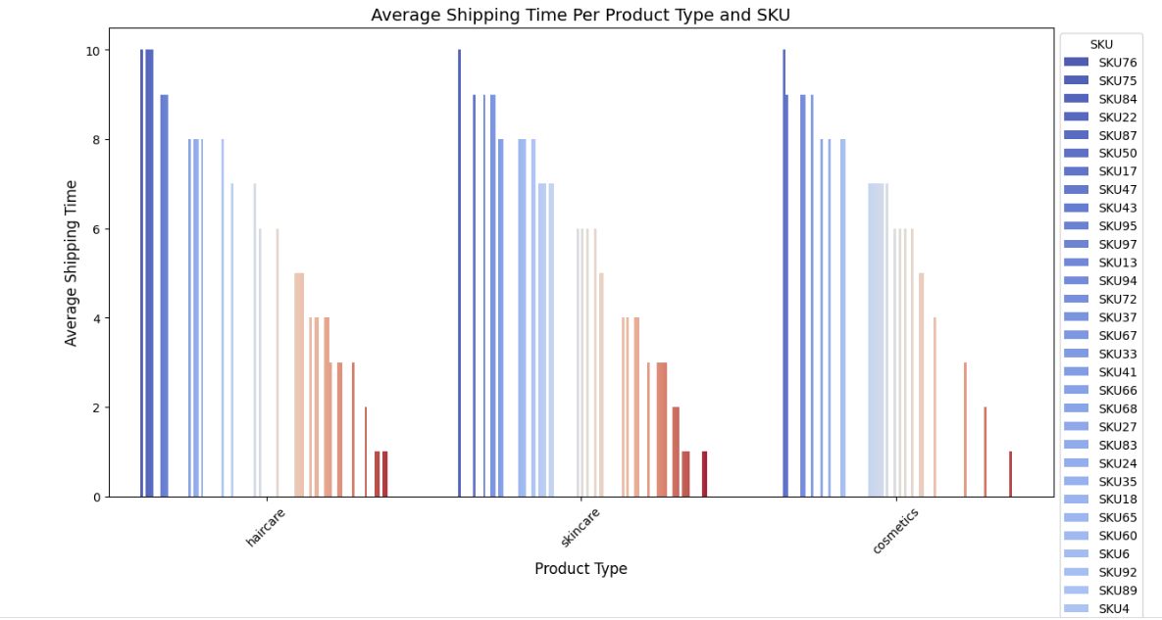 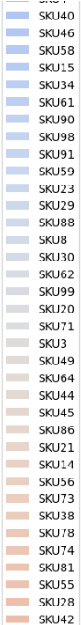 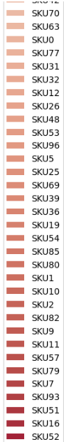

**Skincare products generally have the longest shipping times, while cosmetics and haircare have slightly lower averages.** The bar chart highlights SKU-level variations in shipping time.

1. How do shipping costs vary across different transportation modes?

(SQL) (Python)

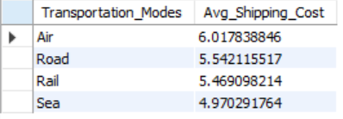 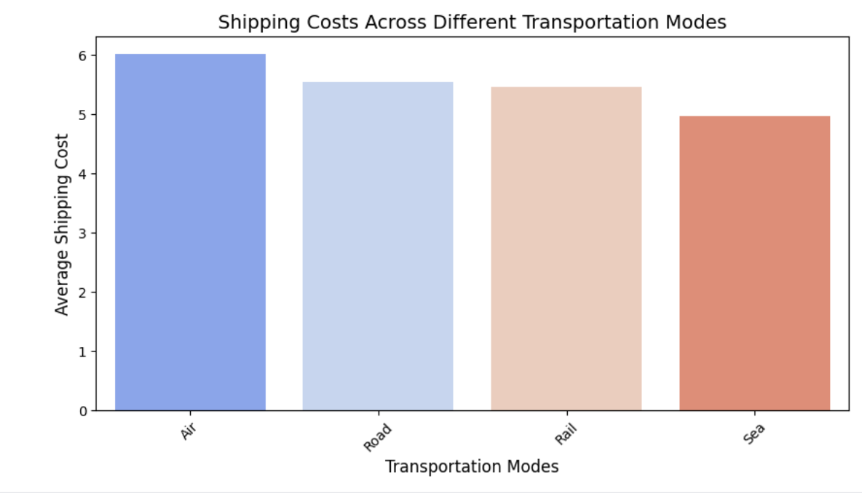

**Air transport has the highest shipping costs, while Sea is the most cost-effective mode.** The bar chart confirms this trend, helping optimize transportation choices.

1. What is the most cost-effective transportation mode for each product category?

(SQL)

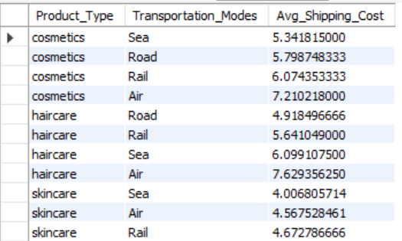 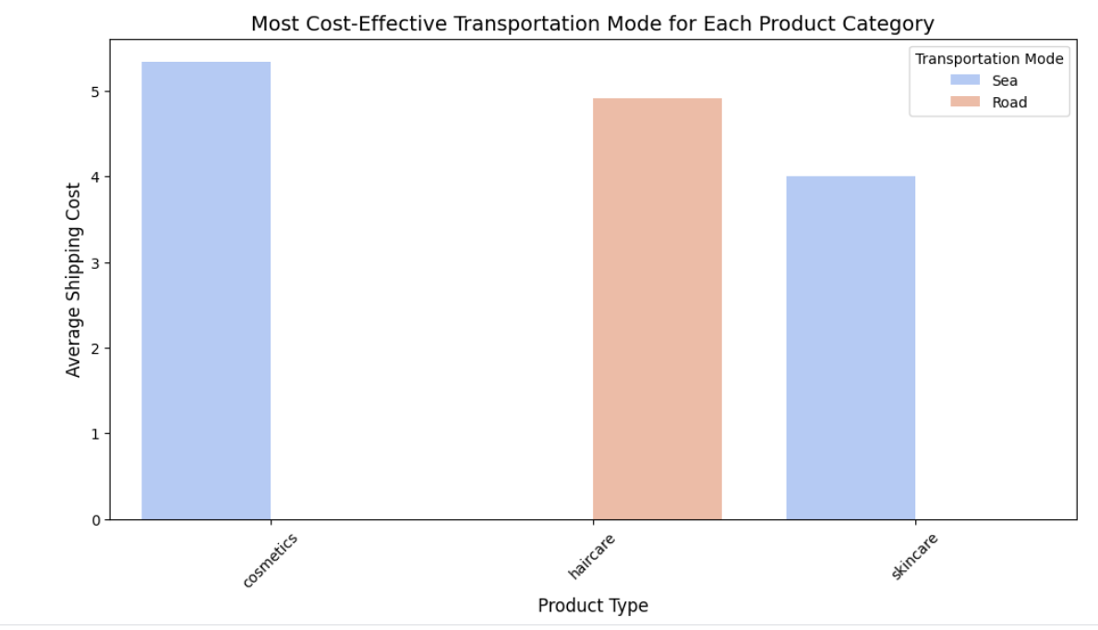

**Sea and Rail are the most cost-effective transportation modes for cosmetics, haircare, and skincare.** The bar chart highlights the lowest shipping costs for each product category.

1. Are there significant delays in shipping times due to specific routes or carriers?

(SQL) (Python)

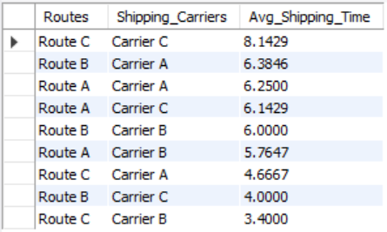 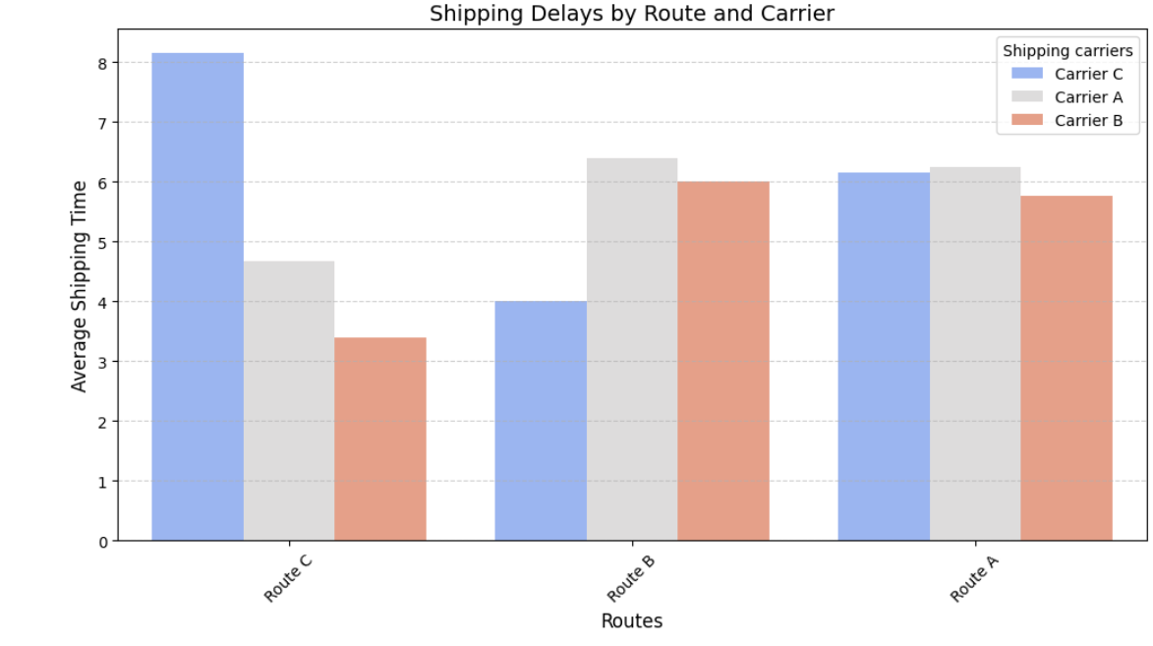

**Route C with Carrier C** experiences the **longest shipping delays** (8.14 days), while **Route C with Carrier A** has the shortest shipping time (3.4 days). **Significant variations exist across routes and carriers, indicating potential inefficiencies.**

1. A graph of shipping costs

   AI-generated content may be incorrect.How do shipping carriers impact shipping costs?  
     
   (Python)  
   The bar chart shows that all carriers (Carrier A, Carrier B, and Carrier C) have the same average shipping cost of around 5, indicating that the choice of shipping carrier does not significantly impact shipping costs in this case, and other factors like speed or reliability should be considered for decision-making.

**Customer & Market Trends**

1. Which customer demographics purchase the most products?

(SQL) (Python)

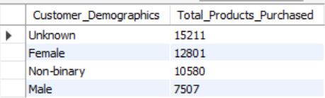 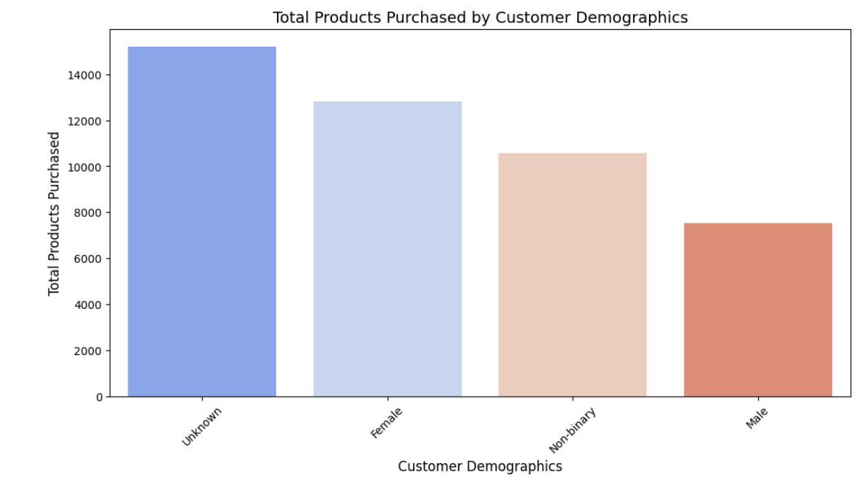

**The 'Unknown' and Female demographics purchase the most products, while Males buy the least.** The bar chart confirms this pattern, showing clear purchasing differences across customer groups.

1. What is the relationship between customer demographics and order quantities?

(SQL) (Python)

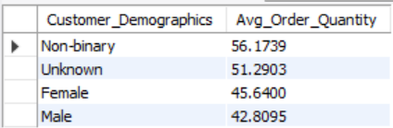 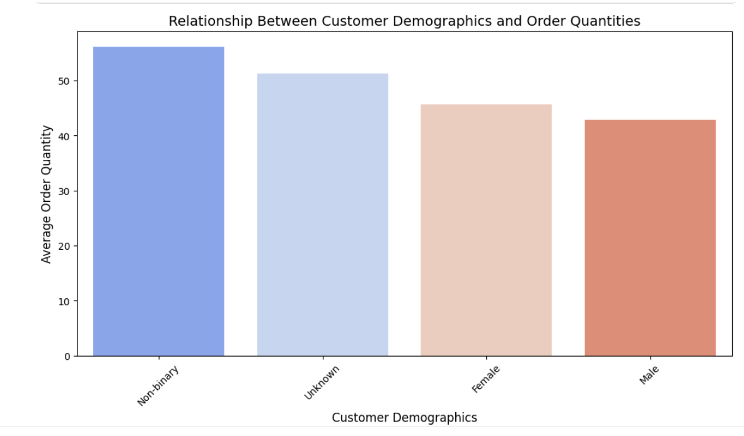

**Non-binary and 'Unknown' customers place the highest average order quantities, while males order the least.** The bar chart confirms this trend, indicating demographic-based purchasing behaviors.

1. Are certain product types more popular in specific locations?

(SQL) (Python)

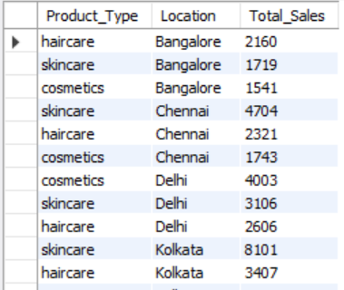 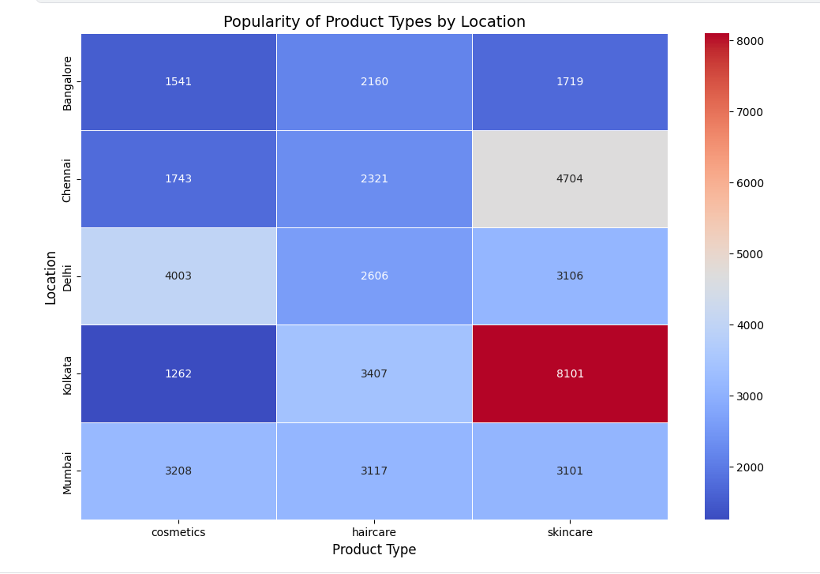

**Skincare is most popular in Kolkata, while haircare dominates in Bangalore and Chennai.** The heatmap confirms regional product preferences for optimized inventory.

1. How do shipping times and costs affect customer purchasing behavior?

(SQL) (Python)

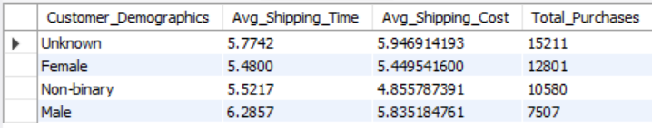 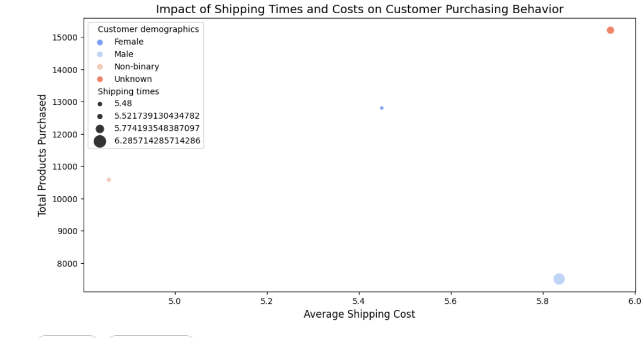

**Customer demographics with lower shipping times and costs tend to make more purchases.**  
The "Unknown" and "Female" categories show the highest purchases, correlating with relatively lower shipping costs and times. **Longer shipping times (e.g., Male) are associated with fewer total purchases, indicating that faster delivery improves customer purchasing behavior.**

1. How do product categories impact revenue?  
     
   (Python)  
   A graph of a bar chart

   AI-generated content may be incorrect.  
   The bar chart shows that the "Unknown" demographic purchases the most products at around 14,000, followed by Females at 12,000, Non-binary at 10,000, and Males at 7,000, suggesting that marketing strategies should focus on better identifying customer demographics to target Females and Non-binary groups more effectively, while investigating why the "Unknown" category is so high.

**Cost & Efficiency Optimization**

1. How do lead times impact revenue generation?

(SQL) (Python)

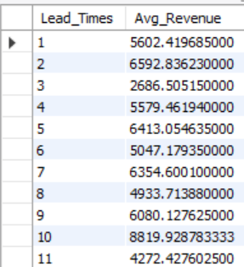 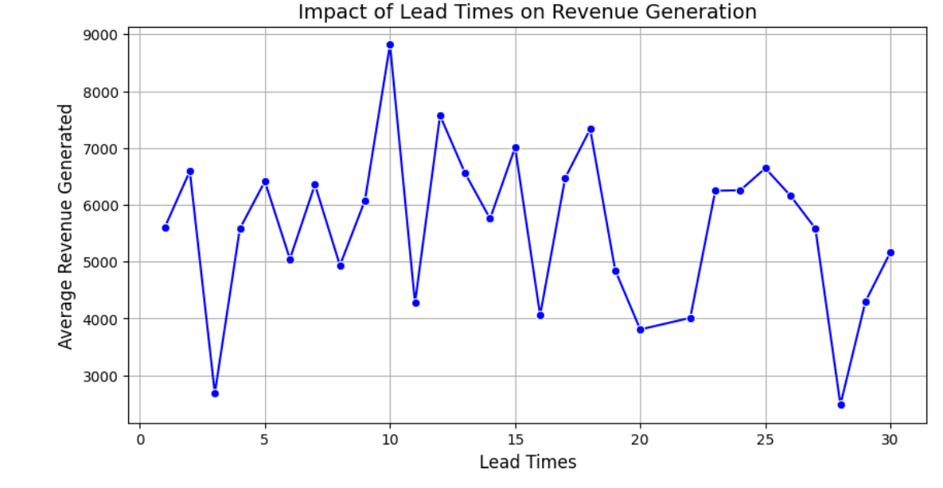

Revenue generation fluctuates with lead times, showing no clear linear correlation. However, shorter and moderate lead times generally correspond to higher revenue, suggesting that reducing lead times may improve sales.

1. Are there cost-saving opportunities by switching suppliers or shipping carriers?

(SQL) (Python)

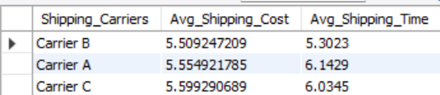 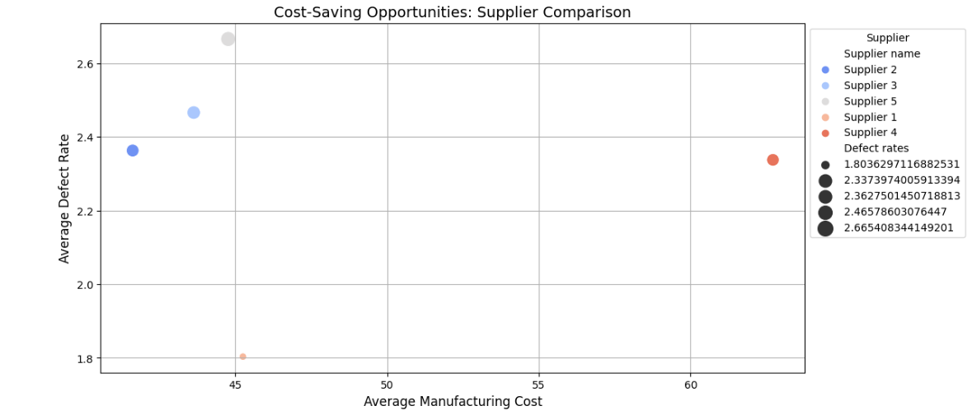 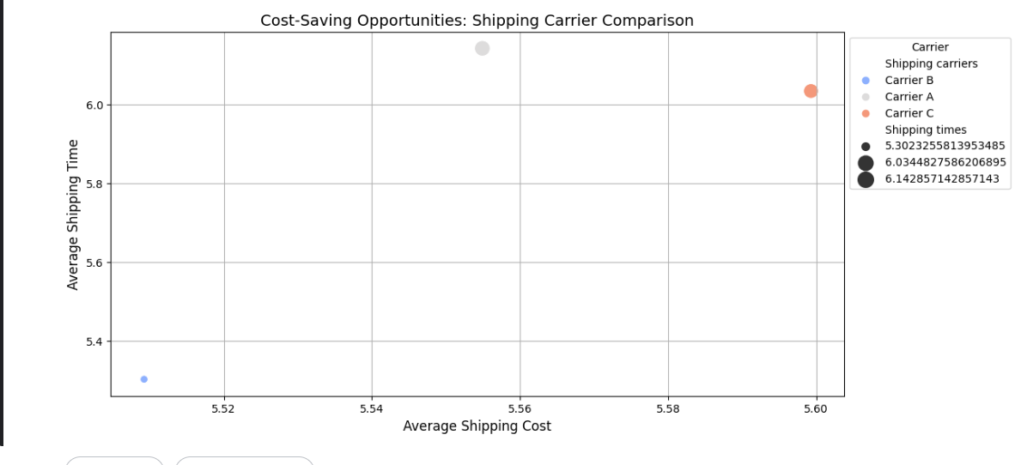

**Carrier B** offers the **lowest shipping costs and fastest delivery times**, indicating a cost-saving opportunity by switching from **Carriers A or C**. Similarly, evaluating supplier costs and defect rates can **help identify more efficient alternatives**.

1. What are the costliest elements in the supply chain?

(SQL) (Python)

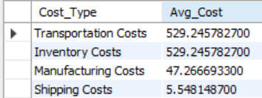 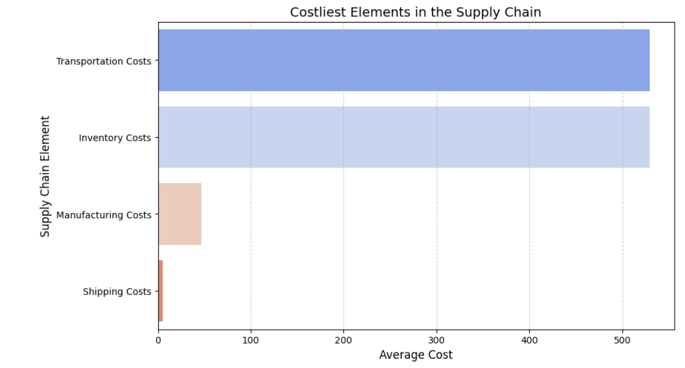

Transportation and inventory costs are the most significant expenses in the supply chain, while manufacturing and shipping costs are relatively lower. Optimizing transportation and inventory management could lead to major cost savings.

1. What strategies can be implemented to reduce defect rates?

(SQL) (Python)

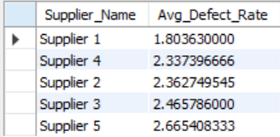 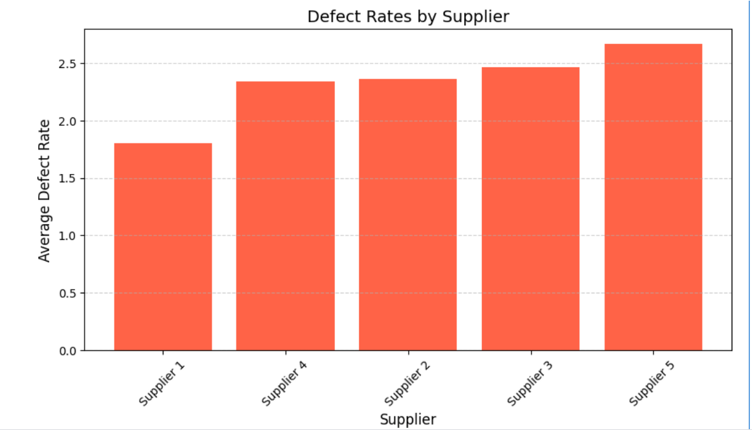

**Supplier 1** has the **lowest defect rate (1.80)**, while **Supplier 5** has the **highest (2.67)**. Strategies to reduce defect rates include **enhanced quality control, supplier audits, and process improvements.**

1. How do transportation costs impact overall profitability?

(SQL) (Python)

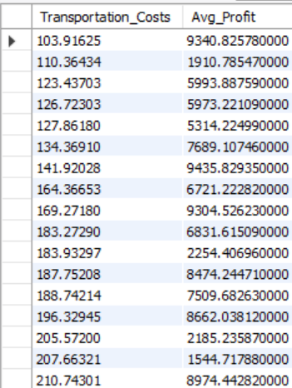 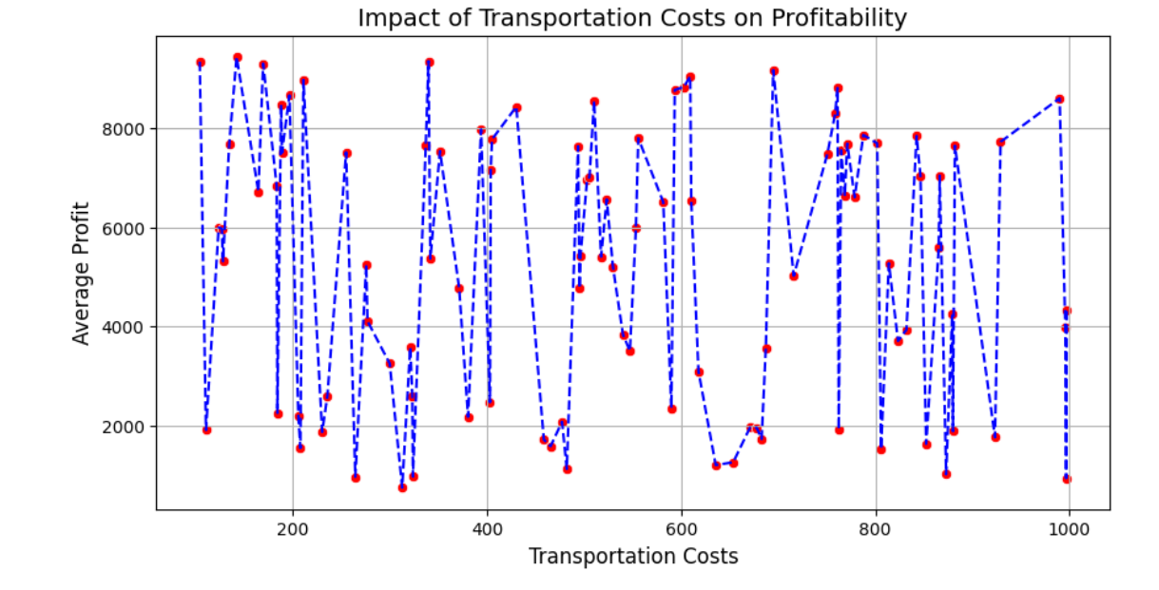

Higher transportation costs do not show a clear correlation with profitability, as profits fluctuate across different cost levels. This suggests that other factors also influence overall profitability.